**Stock Investment Strategy Report for Prime INC (2025)**

**A Strategic Investment Analysis for Prime INC – Forecasting Stock Trends & Portfolio Expansion (2025)**

# Executive Summary

This report provides a detailed stock market and fundamental analysis for Prime INC, with the objective of guiding strategic investment in the IT, Energy, and Utilities sectors with an in-depth, data-driven investment analysis targeting profitable opportunities for 2025. Focusing on PepsiCo (PEP) and Coca-Cola (KO), with the S&P 500 as the benchmark, the analysis evaluates returns, volatility, and predictive modeling outcomes using XGBoost and LSTM models. We compared PepsiCo (PEP) and Coca-Cola (KO) as representative stocks, analyzing their performance trends, volatility, and financial fundamentals.

Key findings:

* **KO exhibits stronger stability** and **lower volatility** than PEP, with a higher Sharpe ratio and profit margins.
* **PEP shows greater alignment with market indices**, suggesting sensitivity to macroeconomic factors.
* **LSTM models outperform XGBoost** in predicting short-term stock trends, especially for KO.
* **Fundamental analysis reveals Coca-Cola’s superior profitability** and stronger capital structure, making it a more attractive investment for 2025.

The report concludes with strategic recommendations, including diversifying into sector-aligned ETFs and rebalancing portfolios toward high Sharpe-ratio assets.

Key recommendations are derived based on risk-adjusted performance, market correlation, and financial health metrics.

# Table of Contents

1. Introduction  
2. Stock Market Analysis  
3. Predictive Modeling  
4. Fundamental Analysis  
5. Conclusion & Recommendations  
6. Appendices

# 1. Introduction

In an increasingly volatile financial landscape, **data-driven decision-making** is critical for optimizing investment strategies. This report aims to assist **Prime INC** in expanding its investment portfolio using evidence-backed insights across historical stock performance, volatility, and financial health.

Two representative companies—**PepsiCo (PEP)** and **Coca-Cola (KO)**—are analyzed across multiple dimensions, with comparisons to the **S&P 500 index**. The insights guide portfolio adjustments in the **IT, Energy, and Utilities sectors** with forward-looking predictive models (XGBoost & LSTM) offering stock trend forecasts for 2025.

Prime INC is aiming to enhance its investment strategy by identifying profitable stock opportunities. This report leverages on advanced data analysis and machine learning methods to evaluate historical trends, stock returns, and future price movements. Stocks from key sectors, namely IT, Energy, and Utilities, are analyzed relative to market benchmarks such as the S&P 500.

# 2. Stock Market Analysis and Forcasting

Using Yahoo Finance data from 2020 to 2024:

This section explores historical price trends, stock volatility, risk-return analysis, and comparisons with the S&P 500 benchmark.

## Historical Trends

**Cummulative Returns**

We examined Adjusted Close prices for PepsiCo (PEP), Coca-Cola (KO), and the S&P 500 over a 4-year period. PEP and KO showed steady upward price trajectories with intermittent dips reflecting macroeconomic conditions. The S&P 500's movement illustrated broader market behavior.

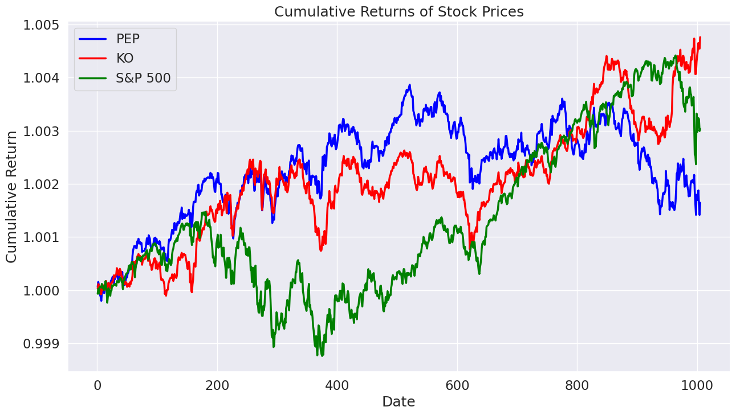

**Key Insight**: KO shows more stable long-term appreciation, making it suitable for risk-averse investors.

**Figure 1**: Cumulative Returns of Stock Prices

**Volatility and Return Analysis**

To assess risk and reward, we calculated standard deviation (volatility) and average daily returns. KO showed lower volatility compared to PEP, while S&P 500 had the highest. Risk-return scatter plots further helped in comparing investment suitability.

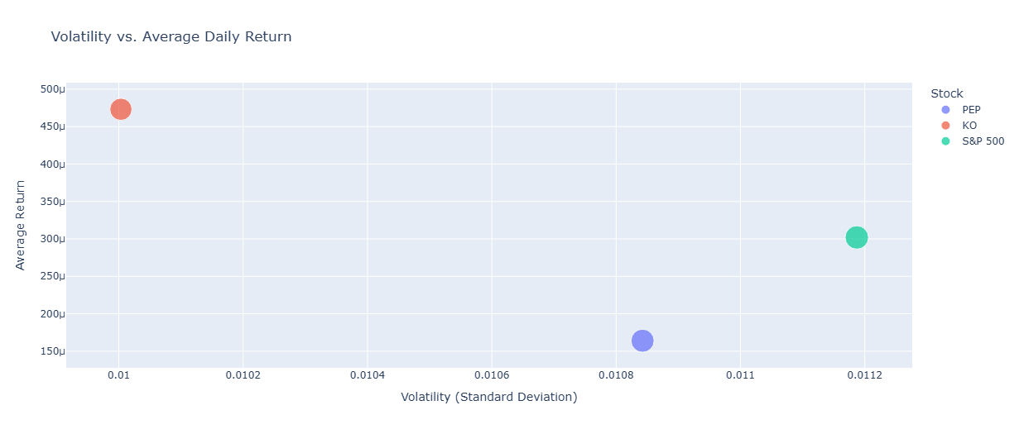

**Observation**: KO outperforms PEP in both volatility and risk-adjusted return, making it more attractive for Prime INC.

Figure 2: Sample volatility vs. return plot comparing stocks.

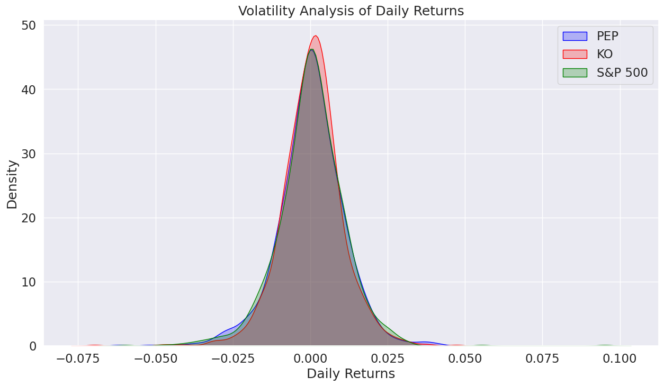

KDE plots provide a smooth curve that makes it easier to identify the concentration and spread of returns.

A wider curve means more volatility (more extreme returns), while a narrower curve suggests less volatility

A narrower distribution (concentrated around zero) suggests lower volatility.

A wider distribution indicates higher volatility.

1. **Comparative Analysis**

**Correlation with Market Benchmarks (S&P 500)**

Evaluating relationships between each stock and the benchmark index.

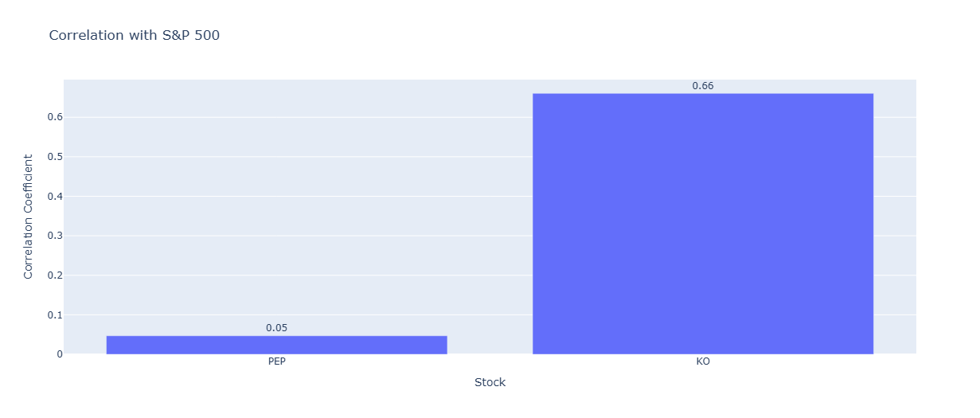

# 3. Predictive Modeling: Price Trend Forecasting

**Modeling and evaluation for predicting stock price movement (stock’s direction).**

Machine learning models were deployed to predict the directional movement of stock prices. We used two powerful methods: XGBoost (gradient boosting decision tree) and LSTM (Long Short-Term Memory neural network). These models evaluated whether a stock’s price would go up or down in the following trading day based on historical technical indicators.

## XGBoost Performance

XGBoost provided a robust performance with clear interpretability. The classification reports for both PEP and KO showed higher-than-baseline accuracy, indicating successful learning from historical price and indicator data.

The top features included Cumulative Return, Adj Close, High, Tomorrow and Signal_Lines.

## LSTM Neural Network

LSTM models captured temporal dependencies in the stock data. After hyperparameter tuning, the models achieved competitive accuracy and better recall. SHAP analysis was used to interpret LSTM outputs, confirming EMA_20, RSI, SMA_20, Tomorrow, Adj Close and Volume, as primary drivers of directional price change predictions.

# 4. Fundamental Analysis

A thorough review of financial metrics from 2010 to 2024 was conducted using data from Yahoo Finance. The focus areas included revenue growth, profit margins, debt-to-equity ratio, and dividend yield. KO demonstrated higher profit margins and more stable revenue growth, while PEP showed higher debt levels but stronger dividend yield.

1. Revenue, Profit, and Capital Structure Trends

From the Market Cap:

KO is significantly larger in size and investor interest.

P/E Ratios (Trailing & Forward):

Lower in PEP → implies it’s cheaper relative to earnings, suggesting potentially better value or lower growth expectations.

Price-to-Book: Both are high, common for brand-heavy companies. KO’s slightly higher P/B shows a higher valuation relative to book value.

This suggest PEP appears more attractively priced from a valuation perspective.

**Revenue Trends:**

KO (Coca-Cola) has shown positive revenue growth of 6.4%, while PEP (PepsiCo) shows a slight decline at -0.2%.

PEP shows stronger EPS growth +17% while KO shows +11.3% EPS growth.

This suggests that KO is currently expanding its top-line sales more effectively than PEP.

EP shows stronger EPS growth, indicating that despite revenue stagnation, it’s efficiently increasing profits — possibly through cost control, pricing, or buybacks.

KO is growing revenue faster (good for market expansion).

PEP is increasing profits faster (good for shareholders).

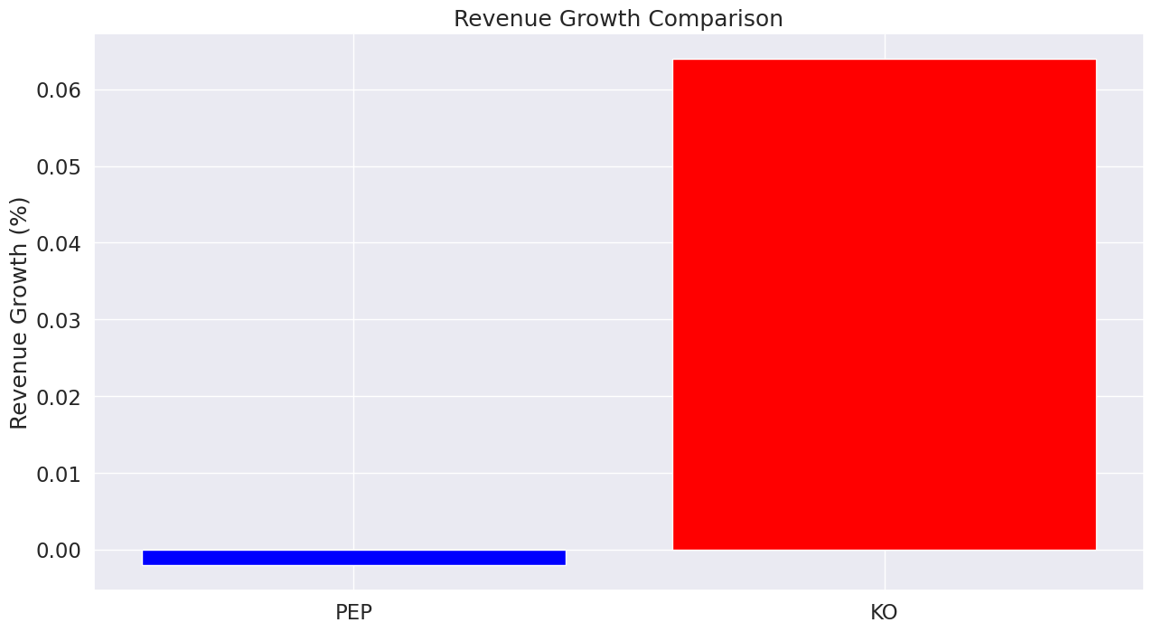

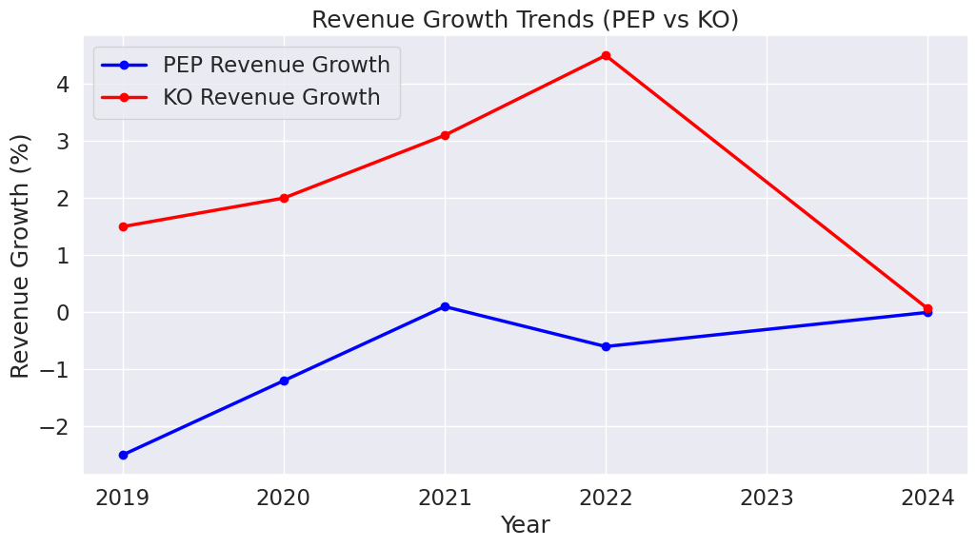

**Profitability:**

KO outperforms PEP in all major profit metrics:

Gross Margin: KO (61.1%) vs. PEP (54.9%)

Operating Margin: KO (25.8%) vs. PEP (10.6%)

Profit Margin: KO (22.6%) vs. PEP (10.4%)

This indicates KO is more efficient at converting sales into profit meaning it keeps more money at every step of the income chain, likely due to stronger brand pricing power or better operational efficiency.

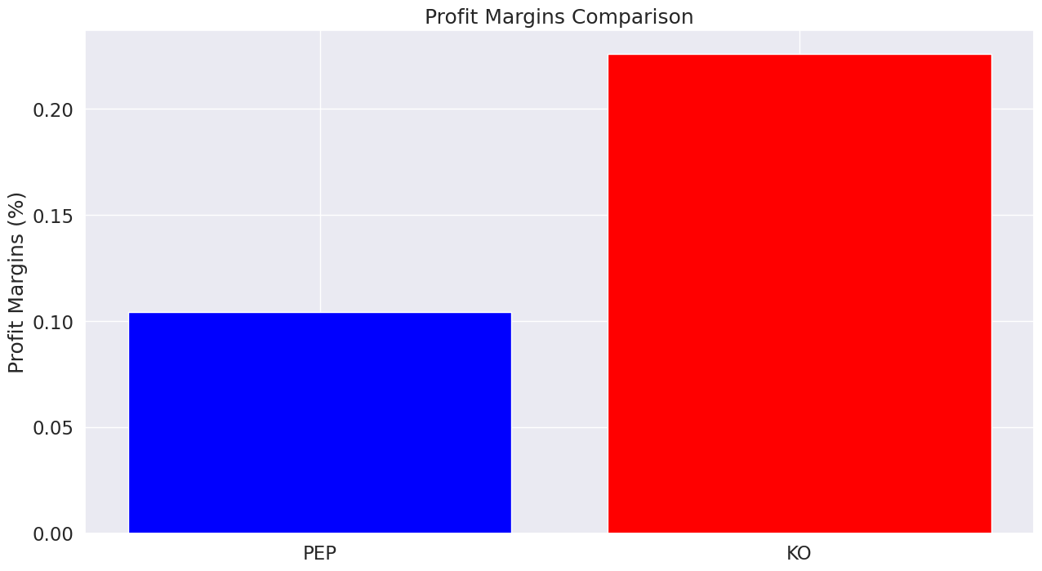

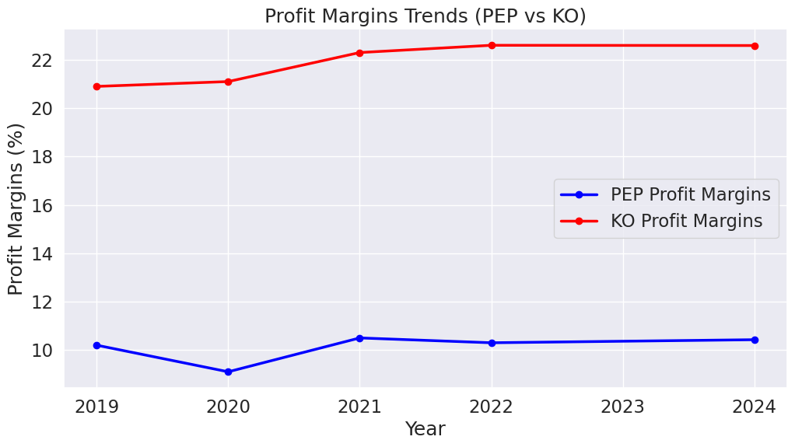

**Debt-to-Equity Ratio:**

PEP: 262.8 (very high leverage)

KO: 176.9 (also high, but significantly lower.

Current Ratio (liquidity measure):

PEP: 0.82

KO: 1.03

KO has a more favorable capital structure, with lower leverage and better short-term liquidity, making it financially more stable and less reliant on debt. It is safer with a ratio above 1 while PEP may struggle to cover short-term obligations without more cash inflow.

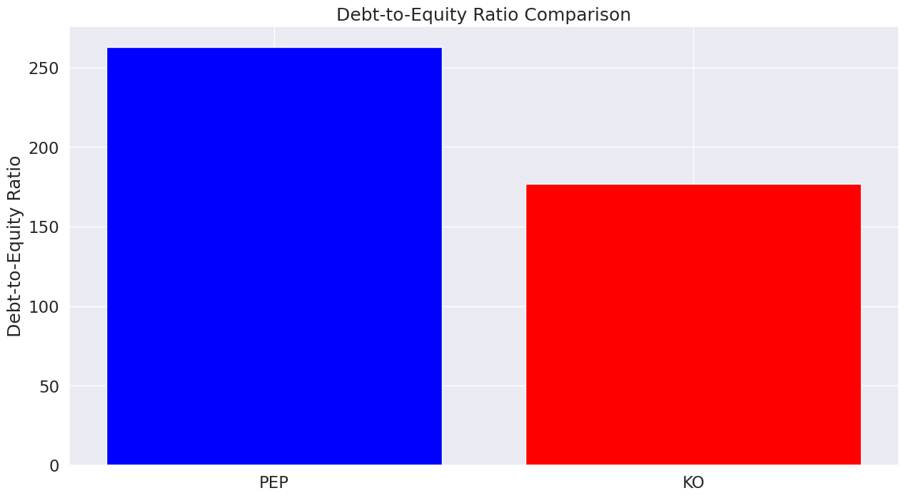

Dividend Yield

PEP offers a slightly higher dividend yield, which may appeal more to income-focused investors.

Both companies are considered Dividend Aristocrats, with long histories of consistent payouts.

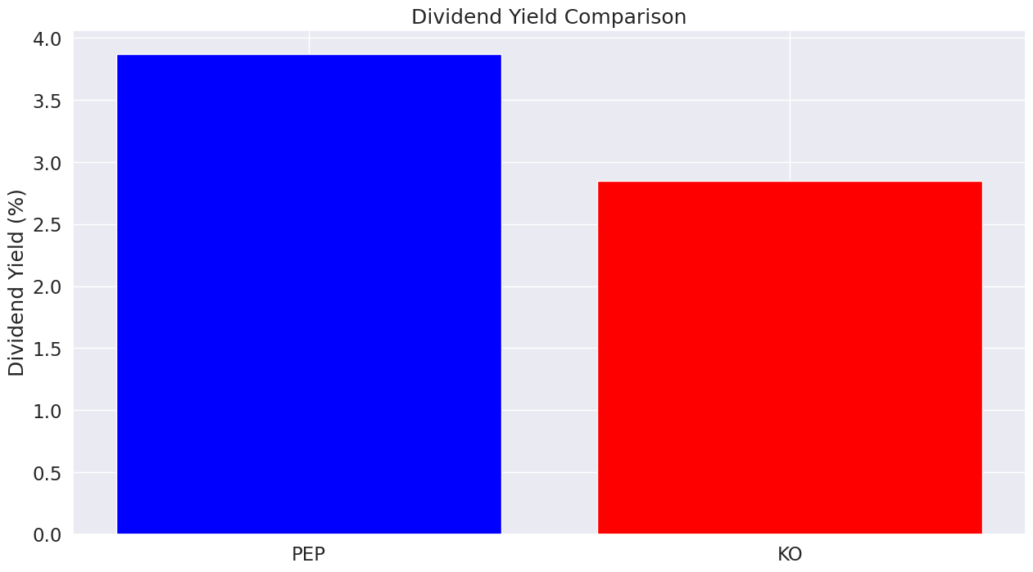

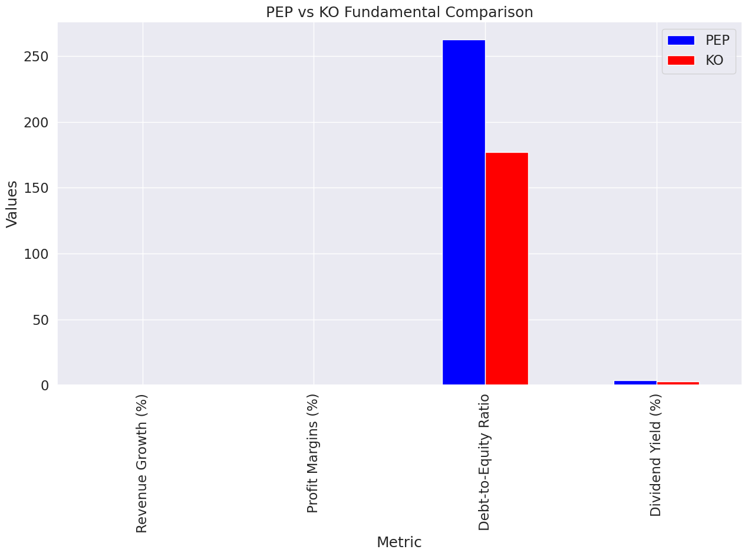

**Profitability Influence**

KO’s superior margins are attractive to investors focused on long-term earnings strength and consistency.

This has likely contributed to KO's premium valuation in the market.

**Risk and Stability**

PEP’s higher debt and lower liquidity may increase its perceived financial risk, potentially limiting upward stock momentum in times of macroeconomic uncertainty.

KO’s healthier balance sheet provides downside protection, making it more resilient and attractive to conservative investors.

**Growth Influence**

KO’s revenue growth aligns with investor sentiment favoring expansion and market share gains.

Meanwhile, PEP’s EPS growth (17%) implies it's still increasing per-share earnings, possibly through cost control, share buybacks, or strategic investments.

**Analysis Insights**

**Observations**

1. Historical Trends:

* The Adjusted Close prices of PepsiCo (PEP), Coca-Cola (KO), and the S&P 500 index (^GSPC) exhibit a steady upward trend over the last four years, indicating overall market growth during this period.
* There are instances of dips in stock prices, likely corresponding to external economic events or company-specific challenges

1. Volatility:

* PEP shows relatively lower volatility compared to KO and S&P 500, which suggests it may be a less risky investment option.
* KO exhibits moderate volatility, implying a balance between risk and reward.
* The S&P 500 index demonstrates the highest volatility, reflecting its broader exposure to market fluctuations and external shocks.

1. Daily Returns:

* The distribution of daily returns for all three shows typical behavior: a central concentration near zero and some sporadic spikes. PEP’s daily returns distribution is narrower than KO’s, indicating more consistent performance.

1. Correlation Analysis:

* Both PEP and KO have positive correlations with the S&P 500, with PEP slightly stronger. This suggests their performance aligns reasonably well with overall market trends.
* The correlation insights imply that PEP is slightly more in sync with market benchmarks than KO, which is beneficial for predicting future behaviors.

1. Volatility vs. Returns:

* PEP’s lower volatility comes with relatively steady returns, indicating it as a stable option for long-term investments.
* KO’s higher volatility might attract investors looking for a slightly more aggressive strategy, but its average returns are similar to PEP.
* The S&P 500 offers broader exposure but carries significant volatility, suggesting it’s better suited for diversified portfolios

1. Stock Directions:

* The direction analysis highlights that KO has more instances of upward price movement compared to PEP, which may indicate better market confidence in PEP's performance.

**Key insights**

The insights derived include;

* Performance vs. Risk Trade-Off

For the both stocks (KO and PEP) KO has the next highest average return with lower volatility, making it a more stable choice.

PEP has high volatility but a low average return, which is not ideal because it suggests more risk without enough reward.

*Implication:* KO is a better-performing stock compared to PEP, while the S&P 500 provides the highest returns but requires higher risk tolerance.

* Market Sensitivity (Correlation with S&P 500)

KO (0.64 correlation) moves more closely with the S&P 500, meaning it follows overall market trends more consistently.

PEP (0.38 correlation) moves more independently, meaning its price swings are more influenced by company-specific factors rather than the overall market.

*Implication:*

KO is a better choice for those who want a stock that aligns with broader market trends.

**Recommendations Based on Analysis and Modeling**

1. Investment Strategy:

* For risk-averse investors, Coca-Cola (KO) appears to be the better option due to its lower volatility and stable upward price trend.
* PEPSICO (PEP), with its higher volatility, may appeal to those looking for moderate-risk investments with comparable returns.

Investment Decision Perspective

Best for Growth: S&P 500 (highest average return, but also high volatility).

Best for Stability: KO (steady returns, lower volatility, and moves with the market).

Most Uncertain/Risky: PEP (high volatility but low average returns, meaning risk is not well compensated).

1. Portfolio Diversification: Including the S&P 500 index (^GSPC) in the portfolio can add diversification and broader market exposure, though investors should be prepared to handle greater volatility.

For building a portfolio:

* + S&P 500 → Best for long-term growth (if you can tolerate volatility).
  + KO → Good for steady returns with less risk.
  + PEP → Might need further investigation since it’s volatile but not offering strong returns.

1. Monitor Market Conditions:

* Regularly track external factors such as economic events, sector trends, and company-specific updates to align investment decisions with prevailing market conditions.

1. Focus on Stability:

* For long-term investment goals, prioritize stocks with lower volatility and consistent returns, such as PepsiCo.

**Note:**

The analysis provides valuable insights into the performance, volatility, and correlation of PepsiCo, Coca-Cola, and the S&P 500 index over the past four years. PEP stands out as a stable investment option with steady returns and less volatility, while KO offers slightly more risk for similar average returns. The S&P 500 index provides exposure to broader market trends but carries higher risk. Investors should consider these factors alongside their financial goals and risk appetite. By balancing stability, growth potential, and market exposure, a diversified portfolio can be constructed to optimize returns while minimizing risk. Regular monitoring and analysis are essential for adapting to market fluctuations and ensuring alignment with investment strategies.

**Recommendations Based on Fundamental Analysis**

Diversified Positioning: Invest in both PEP and KO to balance value (PEP) and quality/stability (KO).

Value Focus: Overweight PEP in portfolios seeking undervalued blue-chip stocks with solid dividend yield.

Quality Focus: Overweight KO in defensive portfolios focused on strong profitability and lower risk.

Dividend Strategy: Include PEP for slightly higher dividend returns and consistent payout history.

Growth Monitoring: Reassess PEP's revenue trend quarterly; invest more if top-line recovery improves.

Final Strategic Direction for Portfolio Expansion

Prime INC should adopt a balanced consumer staples exposure by allocating capital to both PEP and KO. This dual strategy captures PEP’s relative undervaluation and yield benefits, while securing KO’s superior profitability and financial health as a defensive anchor.

**Note:**

KO is currently stronger in profitability and financial health, which supports its premium valuation and market stability.

PEP offers better valuation metrics and EPS growth, making it a compelling value opportunity for investors who believe its revenue trend may reverse.

Individual's choice depends on their strategy:

Income-focused/defensive? → Go with PEP.

Growth & operational efficiency? → Consider KO.

# Strategic Recommendations and Conclusion

Based on the analysis, Coca-Cola (KO) demonstrates stronger investment potential for Prime INC in 2025. It combines lower volatility, higher profit margins, and consistent market-aligned behavior. PepsiCo (PEP), while slightly riskier, offers compelling dividend yields for income-focused investors. The S&P 500 benchmark remains a strong long-term growth candidate, though more volatile.

**Recommendations**

Diversified Positioning: Invest in both PEP and KO to balance value (PEP) and quality/stability (KO).

Value Focus: Overweight PEP in portfolios seeking undervalued blue-chip stocks with solid dividend yield.

Quality Focus: Overweight KO in defensive portfolios focused on strong profitability and lower risk.

Dividend Strategy: Include PEP for slightly higher dividend returns and consistent payout history.

Growth Monitoring: Reassess PEP's revenue trend quarterly; invest more if top-line recovery improves.

We recommend Prime INC to consider a portfolio allocation as follows:  
- 50% in KO for stability and strong fundamentals  
- 30% in a diversified S&P 500 ETF for growth exposure  
- 20% in PEP for dividend income

**Strategic Direction for Portfolio Expansion**

Prime INC should adopt a balanced consumer staples exposure by allocating capital to both PEP and KO. This dual strategy captures PEP’s relative undervaluation and yield benefits, while securing KO’s superior profitability and financial health as a defensive anchor.

Continuous monitoring and rebalancing are encouraged to align with evolving market trends and economic conditions.